# 

**Biometric Authentication of Cattle**

Ohouman Steve Goa

A Thesis Proposal

Harrisburg University of Science and Technology

Fall 2018

# Abstract

Some time ago I came to the painful realization that much of what we perceive about ranching is wrong. Who am I? I am a scientist and professional designer who with a co-authored invention helps you reimagine the farming experience. Why don’t we see biotech products invade that market? According to this paper, this can happen. It’s a world set in motion by new prototypes of AI systems now flocking the startup ecosystem. In this thesis paper, I will present one of the most exciting technologies, in my opinion, to be used by farmers all over the world, from simple muzzle-print features matching devices to advanced computer-aided techniques and the principles built into it. Using biometrics in ranching is a game-changing perspective that will open a new world of possibilities.

Table of Contents

Abstract 2

**Chapter 1: Introduction** 5

Relationship to CPT 5

Relevance 7

**Chapter 2: Background** 13

Key Terms 13

Problem Statement and Justification 14

**Chapter 3: Literature Review** 16

Is It Possible To Identify A Muzzle-print With A Print Reader? 16

The Most Effective Feature-Matching Algorithm 17

Feature Matching 18

Should the RFID Tag Be Replaced? 21

Literature Review Conclusion 23

**Chapter 4: Methodology** 24

Data Collection 24

Sampling 25

Plan for Analysis 25

**Chapter 5: Outputs and Contributions** 27

Anticipated Outcomes 27

Impact of Contributions 27

The Theoretical Model 28

Thematic Analysis 30

Interpreting the Results 32

Reference Guidelines 33

**Conclusion** 35

**References** 37

# **Chapter 1: Introduction**

# Relationship to CPT

My thesis is especially interesting because of the impact it could have on the industry of cattle ranching, on the topic of automated animal ID in general. As modern scientists, we are all fascinated by the idea of object recognition, so I hope my project will satisfy this bit of wonder in the reader’s eye.

Blending areas of product design to ISEM I was able to theorize the modeling of a device that allows the recognition of a cow’s muzzle by the touch. This research proposal sets a narrative for such a device.

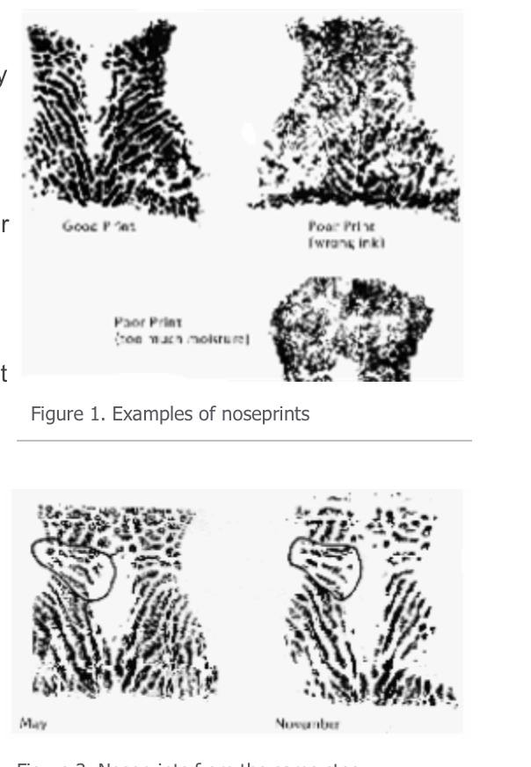

*Figure 1. Examples of nose-prints*

(Oklahoma Cooperative Extension Service, 2004)

# Relevance

Just like the human’s fingerprint, the nose in cattle has been proven to be unique (see figure 1.). Ear tags and tattoos are not the cow’s sole identification systems. Using emerging technologies, it’s possible to authenticate a random pattern that has been stored online. When making these data available to farmers worldwide, archaic tools of authentications will be replaced with another, more suitable for the present days.

If one looks at the market today, one finds there’s no central place for the industry to collect data on bulls. Existing services are expensive, unfocused and lack in usability. Key improvements in genetics, artificial insemination, embryo transfer, feed, medicines, and other technological areas in the cattle industry are still unknown to farmers.

There is a gap to bridge between farmers, the industry and technology. (GobalHarvestInitiative.org, 2016)

Cattle-ranch farmers and the average customer don’t have a place to compare products. Bio tagging comes as a solution to connect ranchers to new technologies. Empower them to make effective decisions.

The goal of this project is an applied study that seeks to solve practical problems when the fields of

information systems and animal branding are assembled. How they are assembled depends on a robust mathematical form called an algorithm. Algorithms are everywhere. They have become central to our daily lives. But there’s still a domain in which we take them for granted, the domain of farming that is. With an algorithm, we find the most efficient way to sort more than a thousand differences in a cow nose print to identify its owner.

1. **Structure and Overview**

In this project, I'm going to show you some of my favorite algorithms and how they have been utilized in the identification of Bovine. How they work. The challenge is to find the fastest and most reliable one. During this process, let’s remember that our level of success needs to reach 93% percent or higher, with 90% being the standard threshold and 93.3% the highest score that has been achieved in such study. (SRGE, 2013)

What these algorithms and technologies might be able to do in the future. How are others been using them? Can the world of farming exist without them? Like many people I am sure, I love animals. I am convinced this project could solve a lot of the ethical issues modern ranching has been accused of. It’s true, we live in an amazing time in history, but we need to match the technological advancement with our evolving intelligence and kindness as well.

A piece of technology that revolutionized our lives today is the cell phone. Most of us carry one of these around. Now, you might have noticed that when you tap the bottom of your screen or take a portrait photo with your phone that it unlocks itself. That component can be attributed to a special face-detection algorithm. This is what mathematicians call feature-matching. Another similar science not so well known by the public but widely used by CG and 3D artists is photogrammetry: The science of making measurements from photographs.

How does this feature-matching case study work to solve our problem?

Well, it’s simple. We will follow this procedure.

We will collect a series of scanned images of muzzle prints. We will be looking for particular  
abstract patterns associated with an individual cow.

When these are detected one after another, it has identified a cow.

This process taps into the underlying pattern behind all nose prints. A process that has been used for many decades. This pattern does not change with the age of the animal.

“Unless the pattern remains the same throughout the life of the animal, the nose print would have little practical use. To ascertain whether or not there is any change in the pattern as the animal grows older, prints have been taken monthly, commencing in October, for five successive months of five calves in the University farm”  
 (W.E.Petersen, 1922)

Phone-based scans are revolutionizing certain fields and are facilitating the collection of other biometric data.

“This year has already seen a multitude of companies propose and launch new systems and devices in the rapidly developing field of wearable biometrics. Smart wearable devices (SWDs) are becoming an increasingly popular form of identification using biometric measurements and are set to replace traditional password and chip and pin authentication methods while continuing to assist both the fitness and medical industries.” (Hill, 2015)

“The advancement in AR and VR technology has been significantly aided by biometric data to better inform upon the experience that they provide - from entertainment right through to retail capabilities. Already, MasterCard envisions a collaboration between AR and biometrics as demonstrated in October's [Money20/20](https://findbiometrics.com/mastercard-shopping-ar-biometrics-410255/) event.

Currently the most widely used application of biometrics functions as a security measure. Meanwhile, entertainment and retail industries are striving to be the industry-leaders in incorporating biometrics into their business.” (Leary, 2016)

1. **Research Objectives**

In this paper, I'll be introducing you to some of the algorithms that have become synonymous with feature matching. But first, I want to find out how these applications can be used by a computer.

Some algorithms like the SURF algorithm are recognized for their accuracy and high fidelity in recognizing images that are rotated or affected by luminosity but creating combinations of these algorithms can produce even more accurate results.

Some cow enrollment and identification techniques have been introduced in the recent years, with the most fruitful being the one introduced by SRGE (Scientific Research Group in Egypt). These tools allow users to derive camera movement and other relative motion from arbitrary footage. On a more technical level I am showing you how I will go about approaching this problem with mathematics. The method used in this project does not terribly differs from this ancient Euclidian algorithm. This ubiquitous algorithm gives us the basis behind pattern-matching calculations. Euclid's Algorithm is a method for finding the greatest common divisor of two numbers. The greatest common divisor is the largest number that will divide a pair of other numbers without leaving a remainder. For example, four divides into both eight and 12 without a remainder. It's simple enough for small numbers but requires much more sophistication for large ones. Now let’s get back to our topic. Imagine the cow nose print is a rectangle made of even smaller parts and you want to find the most efficient way to tile it with square pixels in other words, what's the largest square pixels tile that will exactly divide the dimensions of the rectangle with nothing left over? Basically, the dimensions of the plane are the two numbers and the size of the tiles, which we are trying to calculate is their greatest common divisor. The Euclidian’s algorithm shows us how to find the perfect-sized square pixels tile for this rectangle. According to the Euclidian Algorithm, we need to start by filling the rectangle with square pixels tiles corresponding to the smallest of the two dimensions. This is the first stage of the job. Euclid's Algorithm then tells us to do the same thing again with this rectangle. At each stage, the algorithm tells us to select square pixels tiles corresponding to the shortest side of the rectangle. So, this time, our square tiles perfectly fill the leftover space. For example, if my square pixels tile has dimensions 15 by 15 pixels, Euclid's Algorithm tells us that the greatest common divisor of 210 and 45 is 15.

This simple algorithmic method elegantly exemplifies the basic principles behind my final solution. *An algorithm will be used to match two or more image scans of a single nose print.*

The Cattle ID, once built, will facilitate the collection of data for millions of animals and could even render safe and improve animal branding in the already dangerously inhumane world of farming.

The problem if we define it remains the simple realization that storing the biometric data of cattle is possible, now more than ever. The progress made these recent years in the domain of biometric authentication are complex—And we will be studying them.

# **Chapter 2: Background**

# Key Terms

SIFT: Scale Invariant Feature Transform  
RANSAC: Random sample consensus

SURF: Speeded-Up Robust Features   
BIOMETRICS: body measurements and calculations  
CLOUD-BASED: Applications, services or resources made available to users on demand via the Internet  
IoT: The Internet of things is the network of physical devices that can be manipulated via the internet

Touch ID: iPhone Fingerprint Identification method

FIDO: Fast Identity Online, developed by FIDO alliance. Clients include Apple, Google, Microsoft, Firefox and more.

Web API: A programmatic interface

Micro Python: a lean and efficient Python implementation for microcontrollers and constrained systems

COMPUTER VISION: A field of Artificial Intelligence

OpenCV (Open Source Computer Vision) is a library of programming functions mainly aimed at real-time computer vision.

PYTHON: A multi-purpose software-programming language with simple syntax

MICRO PYTHON: A lean implementation of Python, that is optimized to run on compact electronic boards.

KAPPA STATISTIC: A numerical rating of the degree to which an agreement between independent observers is expected.

ORB (Oriented FAST and Rotated BRIEF): An OpenCV feature-detection algorithm

FLANN: ORB (Oriented FAST and Rotated BRIEF): An OpenCV feature-matching algorithm.

C PROGRAM: A widely used computer programming language, that was first used in 1972

COORDINATES: They are unique numbers in a trio, representing the distance or a degree of an object. There are several types coordinates. A type of color coordinates for example are known as RGB (r,g,b), and they represent the value of red, green, and blue of an object

MICROCONTROLLER: A compact computer-integrated circuit.

# Problem Statement and Justification

Can we authenticate a cow with a computer-aided technique?

How much fidelity and accuracy could be expected from this new authentication method?   
What are the current biometrics methods available in tech and what are their limitations?

Can we come up with a more accessible and user-friendly way to replace the current technologies?

The solution to the problems expressed above is a successful business opportunity. This work will allow the creation of a large online database for millions of cows. Furthermore, it’s true that today’s methods of livestock branding could use the reliability and permanency of a cloud-based storage.

The project will revolve around **2 major phases**

**Phase 1**

* Authentication platform requiring physical touch
* Sensor is connected to the Internet (IoT)

**Phase 2:** (Contactless) Feature matching of muzzle-print photographs

**The deliverables will include:**

2D illustrations & design of a real-life muzzle print reader

Presentation of related studies   
Comparison of different computer-aided methods chosen for our process   
Complete study of ASIFT and SIFT, RANSAC, and SURF

Precision Data:   
         Training phase (Collecting/Preparing collection)   
         Testing Phase (Retrieval/Application)   
Evaluate the results:   
         Extraction time/ Matching Time/Features   
         Do the Matching scores justify the existence of our system of authentication?

This project is an applied study that seeks to solve practical problems when the fields of information systems and animal branding are assembled.

This paper will not present new algorithms to demonstrate the reliability of biometric authentication. This paper will not present a working mobile application. This paper is not a theoretical study but rather the matching of already-existing technologies or algorithms to create a new way of solving the problem mentioned above.

Hypothesis: Can we authenticate a cow with a computer-aided technique? Can we integrate a muzzle-print authentication platform (reader) to the iPhone?

# 

# **Chapter 3: Literature Review**

# Is It Possible To Identify A Muzzle-print With A Print Reader?

“Modern fingerprinting ID systems require less than half a second to recognize and check a fingerprint.” (Finkenzeller, 2010). This simply means my biometric system will need to be as fast to prove a success. Although my system is just chimerical for the moment, some techniques exist to evaluate such a new system. Techniques that use standardization tests and metrics—e.g. “The EER metric is a powerful metric which allows easily comparing and evaluating biometric systems.” (Giot, El-Abed, & Rosenberger, 2013)

In **Phase 1** of this project, I will oversee the development of a muzzle print authentication device with a mechanism similar to the Touch ID (iPhone Fingerprint reader) & FIDO (Fast Identity Online)—FIDO technology is designed to work with Web browsers and Web-based application.

Some mega-tech corporations today are leveraging the power of biometrics in ways that were not possible before. The consultancy company Google Intelligence, which specializes in security including Mobile, Authentication, Identity, Biometrics, Internet of Things, has anticipated an ecosystem in which built-in tech and sensors are integrated into mainstream consumer devices. Research shows that financial services and the healthcare industry are expected to lead in that domain. (Goode, 2015)

With Apple and Google opening up their Fingerprint reader technology to developers, the market for web-based biometric authentication devices has grown exponentially. (Fontana, 2015)

# The Most Effective Feature-Matching Algorithm

**Phase 2**: This phase involves the contactless authentication of muzzle-print images.

Cattle identification can be made by collecting muzzle images and using an algorithm to sort them. Such electronic method was developed by the SRGE (Scientific Research Group in Egypt). The computer algorithm SIFT (The scale-invariant feature transform) commonly used to identify pixelated images can be applied to any picture taken of a muzzle. To judge of their accuracy, I will be pairing different algorithms. Framing and many other variants will be introduced.

Also, the SRGE has generated a complete system that allows: The enrollment of the cow, it’s matching of identity, and a decision maker that will either accept or reject the info transmitted. (SRGE, 2013)

Although I agree with the topic breakdown by the SRGE, I think the problems below are worth mentioning:

One, what are the limitations of using image capture in this context?

Two, how easy is it to build a frontend for these algorithms?

Moreover, additional materials point to the fact that image matching isn’t a straight venture. According to Springer in his book *Introduction to Biometrics,* the greatest disadvantages in the field are the misuse of storage. (A. K. Jain, 2011). He writes that biometric-based authentication applications have a positive effect on the economy and should be avidly sought for. The theme of biometrics touches a wide variety, “Workstation, network, and domain access, single sign-on, application logon, data protection, remote access to resources, transaction security and Web security.” Therefore, trust in these electronic transactions is essential to the healthy growth of the global economy. “[…] Utilizing biometrics for personal authentication is becoming convenient and considerably more accurate than current methods (such as the utilization of passwords or PINs).” (A. K. Jain, 2011)

# Feature Matching

**1. SIFT vs RANSAC**

*Beyond the theoretical, you must wonder what’s the practical way of building a system?*

Well, in our specific case, the detailed research made by SRGE showed that pairing the SIFT algorithm with the Random Sample Consensus (RANSAC) algorithm can deliver higher accuracy than most traditional methods of image matching. In fact, the score is 93.3% compared to 90%. (SRGE, 2013)

.

*What is RANSAC and why is it important for this project?* “RANSAC is a resampling technique that generates candidate solutions by using the minimum number observations”

*How does RANSAC differ from SIFT?* According to Derpanis, they are both very similar. They make use of feature matching and are applicable to pictures. A simple way to put it would be that RANSAC can better calculate image depths. This last bit is especially important because, with muzzle-prints, the engineer deals with an image projection that abhors smoothness and evenness. (Derpanis, 2010)

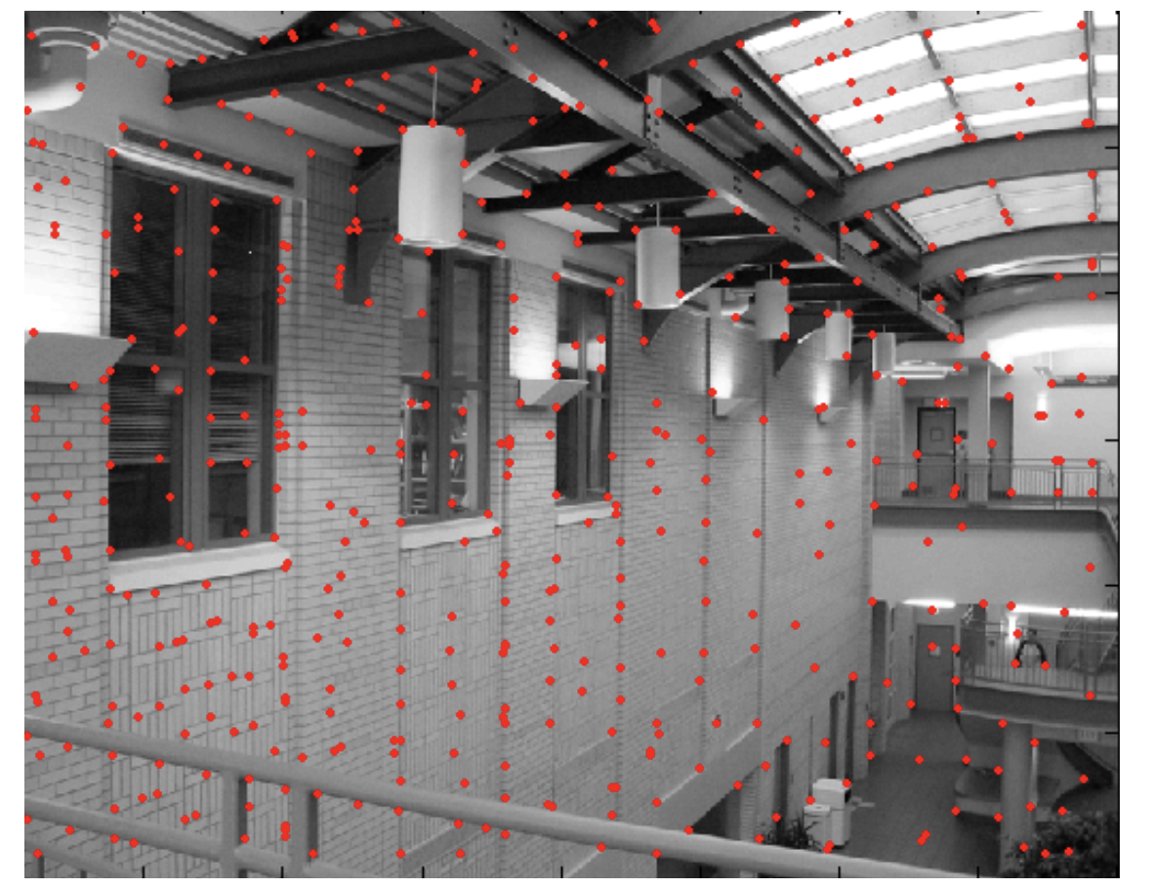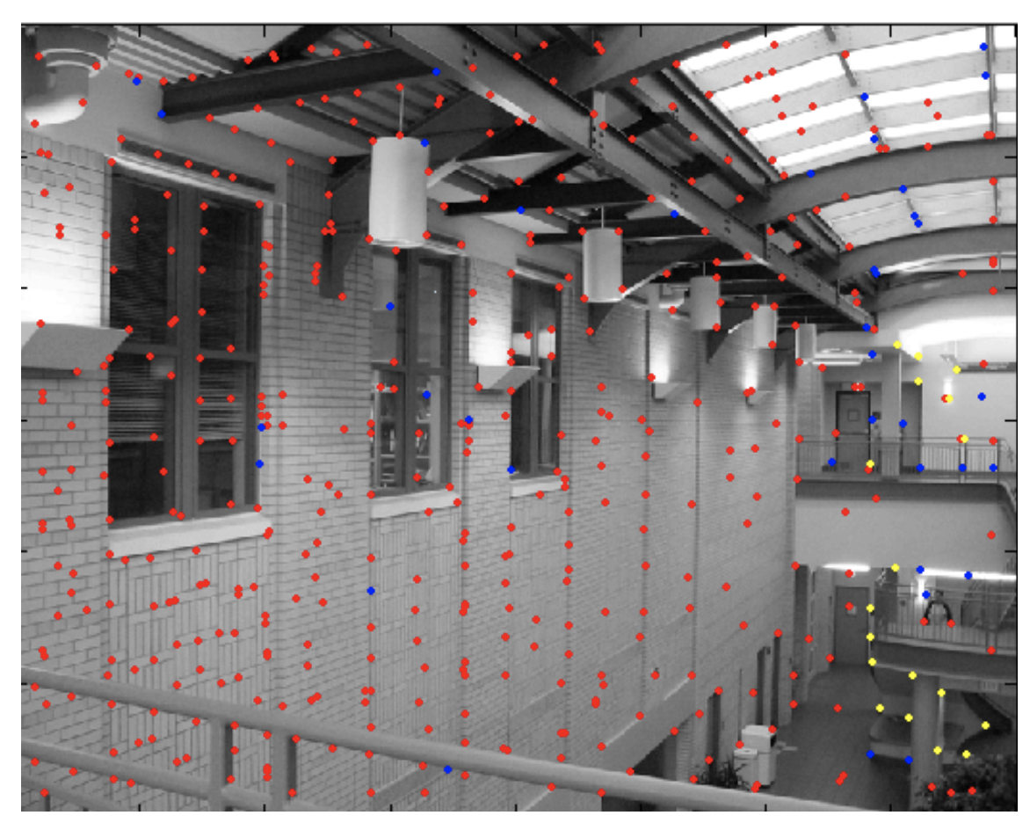

*Figure 2. SIFT VS RANSAC* (Derpanis, 2010)

**2. Speeded-Up Robust Features (SURF)**

Another system of image authentication I will be exploring is SURF for its accuracy and high fidelity in recognizing images that are rotated or affected by luminosity.

“Experiments for camera calibration and object recognition highlighted SURF’s potential in a wide range of computer vision applications. In the former, the accuracy of the interest points and the distinctiveness of the descriptor showed to be major factors for obtaining a more accurate 3D reconstruction or even getting any 3D reconstruction at all in difficult cases. In the latter, the descriptor generalizes well enough to outperform its competitors in a simple object classification task as well.” (Zurich & Leuven, 2008)

Noviyanto and Arymurthy write, “With a sufficient training data, the performance of the original SURF can be more than 0.9 in accuracy and kappa statistic.” (Noviyanto & Arymurthy, 2012)

The figures below are examples used in a SURF experiment.

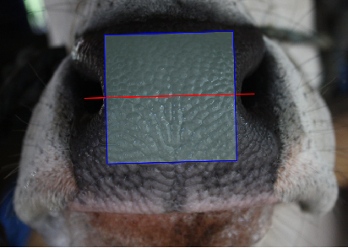

*Figure 3. A 200X200-pixels crop of a muzzle photo, and the current standard for the experiment.*

(Noviyanto & Arymurthy, 2012)

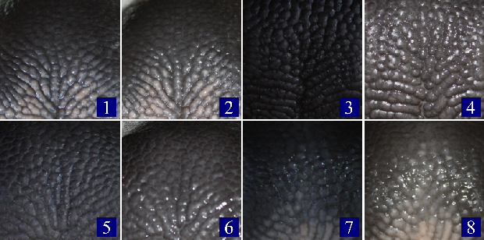

*Figure 4. The sample submitted to 8 different illuminations.* (Noviyanto & Arymurthy, 2012)

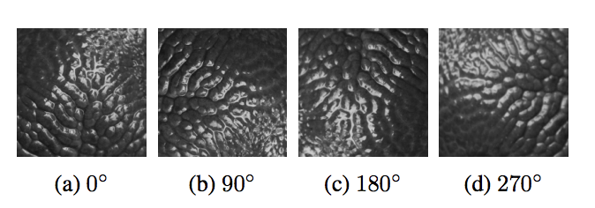

*Figure 5. Our standard sample submitted to 4 different rotational movements*

(Noviyanto & Arymurthy, 2012)

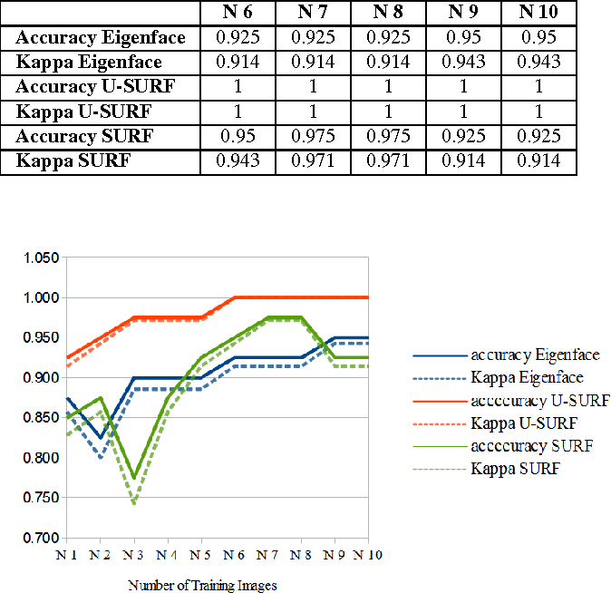

*Figure 6. The table above shows the rate of success/accuracy of the SURF systems discussed by the authors. The SURF approach can be a better method for an automatic cattle identification based on the experiments above.* (Noviyanto & Arymurthy, 2012)

# Should the RFID Tag Be Replaced?

1. **Advantages of RFID**

Electronic IDs are widely used in the western world. In the US, there have been efforts to create a standard and extensive system of identification and data retention. Such efforts are important because they could prevent diseases to spread. Farms and ranches use very sophisticated tools for cattle management. Our ideas of what a cattle ranch should look like are sometimes romantic and don’t catch up with the reality of this sector, which has become very tech savvy. A game changer in the domain was the introduction of Radio-frequency identification (RFID), which employs a reader/scanner, data accumulator, a software/data management system, and a simple electronic ID system. By simply attaching an electronic ear tag to the animal, the farmer or the engineer can connect to their system.

**2. Disadvantages of RFID**

One disadvantage of using RFID systems is the frequency and the range operated under such systems are not scalable features. Even the speed of the transponder in the acting zone of the reader is dependent on several factors. (Finkenzeller, 2010) For instance, notice that the reading speed of an electronic ear tag is very low since the farmer is guided to the reader by hand.

There is also the problem of interference, for which Finkenzeller writes,

“The range of products that have their own resonant frequencies (e.g. cable drums) presents a great challenge for system manufacturers. If these resonant frequencies lie within the sweep frequency 8.2 MHz +- 10% they will always trigger false alarms.” (Finkenzeller, 2010)

The limitations of the RFID method are of course numerous. The obvious being that RFID-enabled tags can indeed be duplicated. Worst yet, Noviyanto and Arymurthy observe that the ear tag will disintegrate the cow’s ear in long-term usage or alter the appearance of the ear, which create disvalue for an animal that will, for example, be eventually discarded from a religious offering. (Noviyanto & Arymurthy, 2012). One main argument for the use of a cloud-based biometric system over the RFID method is the case for economic growth. Indeed, the priority of the farmer and the engineer should be to connect the animal to the internet. The world economy is moving towards just that—e.g. IoT (internet of things).

# Literature Review Conclusion

Just like the iPhone fingerprint-unlock, the muzzle touch reader can become a reality. One reason such a prototype was not made public yet might involve questions of accuracy or feasibility, but this thesis presents several simulations that have successfully recognized and checked the muzzle of a cow. One of the problems with the different algorithms mentioned above is the implementation of a backend. That’s why, in the course of this study, I will be investigating a very interesting work by researchers at the University of Stanford—Mobile Device Identification via Sensor Fingerprinting, implemented by an accelerometer-based fingerprint—for which the inventors write,

“Our accelerometer-based fingerprint is especially interesting because the accelerometer is accessible via JavaScript running in a mobile web browser without requesting any permissions or notifying the user.” (Bojinov, Boneh, Michalevsky, & Nakibly, 2015)

Finally, a matter of great interest in the topic of AI (Artificial Intelligence) for biometrics, which I did not detail in this research proposal, is MicroPython for, one, its power of automation, two, its storage ability for massive lines of codes on a tiny surface, and three, its ease in being reproduced and used in the domain of IoT—e.g. the Touch Reader.

# **Chapter 4: Methodology**

# Data Collection

I am developing this Cattle ID project with the ingenious Python and the exciting OpenCV. Python is a multi-purpose software-programming language that is truly versatile while OpenCV is a library of programming functions mainly aimed at real-time computer vision.

The OpenCV documentation describes it as “…free for both academic and commercial use. It has C++, C, Python and Java interfaces and supports Windows, Linux, Mac OS, iOS and Android. OpenCV was designed for computational efficiency and with a strong focus on real-time applications. […] Enabled with OpenCL, it can take advantage of the hardware acceleration of the underlying heterogeneous compute platform."(OpenCV, 2018)

New advances in computing power have meant today’s computers can search billions of color channels simultaneously. But the trouble is that looking for matching features isn't quite as simple as we might imagine.

“The computer doesn't really understand what's shown on an image — it just sees digits representing color values.” (Zhang, 2018)

When you have a colored image, there will be three color values for each coordinate. So, imagine all those different color values stretched out, it would be too costly for the processor. With thresholding we can filter values that are in between certain ranges. (Zhang, 2018)

*So along this side you've got all the very small stuff. So, you've got a background. You've got viewpoint change. You've got illumination change, blurring and rotation.* And you need to filter that noise. (Mordvintsev & K., 2013)

# Sampling

For this experiment we will look at a single cow, we will refer to as “Roussette,” with several training samples taken of her muzzle. One factor that is known is the rate of accuracy delivered by most traditional methods of image matching, which is 9 in 10 (SRGE, 2013)

In Chapter 6, I will lay out the foundation to determine the rate to which the system successfully identifies Roussette’s nose from different illuminations, and the number of times the system successfully identifies that image submitted to different rotational movements.

# Plan for Analysis

In this section, I am briefly citing what’s needed to be able to predict the success rate in our muzzle print experiment. The accuracy of such experiment depends on several factors. And we can even use those actors to form a measurement. *See Chapter.6: Thematic Analysis*

**Why Python?**

Before we start. Here is the reason why I’m using Python and not anything else.

“Why do I think Micro Python is worthy of your consideration? The Internet of Things is not going away, and Python enhances embedded development, making it quicker to bring products to market. I’m fairly certain there are many more Python developers out there than C, thanks to Python’s mainstream popularity (even if it can’t compete on execution speed with C programs). If you’re interested in building for the next generation of devices, this implementation is well worth checking out.” (Bolton, 2017)

This last bit especially resonates because the goal of this project is to build an Internet-of-Things device for your smartphone. Also, the validity and quality of results will be measured with a series of calculations and tables. First, I will record the evaluation made on Roussette’s muzzle image. Second, I will generate a simple table to analyze matching scores and their relations to the original input image. Finally, I can establish a report depicting the probability of success for using the method discussed in this project.

# **Chapter 5: Outputs and Contributions**

# Anticipated Outcomes

Our specific methods of evaluation will be looking at some of the examples we already know, SIFT and SURF. But it doesn't necessarily make an *automatic cattle identification system* itself any more likely with these two. SIFT is less effective at calculate depth, as earlier mentioned, while, “SURF is good at handling images with blurring and rotation, but not good at handling viewpoint change and illumination change.” (Mordvintsev & K., 2013)

The anticipated results will show that data can be utilized to develop an identification scheme. The artifact built will be a prototype of a muzzle print that has been copied, stored and retrieved via mobile technology, using OpenCV algorithms.

# Impact of Contributions

Each facet of this bio tagging system represent a leap forward from its predecessors. *So, you’ve got a phone app; you’ve got this peripheral device, and it’s a non-invasive way to record and retrieve IDs, and it’s all painless.* But that’s assuming the technology is regarded as cost-effective. That is, it can be afforded by most ranchers, if not all. But how do we know that? Maybe farmers are not ready for our tool, maybe instead of being the replacement, a cloud-based ID system is just an option. If we confirm this idea that bio tagging is a far more versatile business option, can we assume with a little more certainty that a smart plugin would be worth the investment. In August 2017, the USDA reported that 73 percent of farms have access to a computer and 39 percent of producers use smartphone for farm business. (USDA, 2017)

# The Theoretical Model

Breeds muzzle pattern are proven to be unique for each cattle. Muzzle print are in fact like the human’s fingerprint.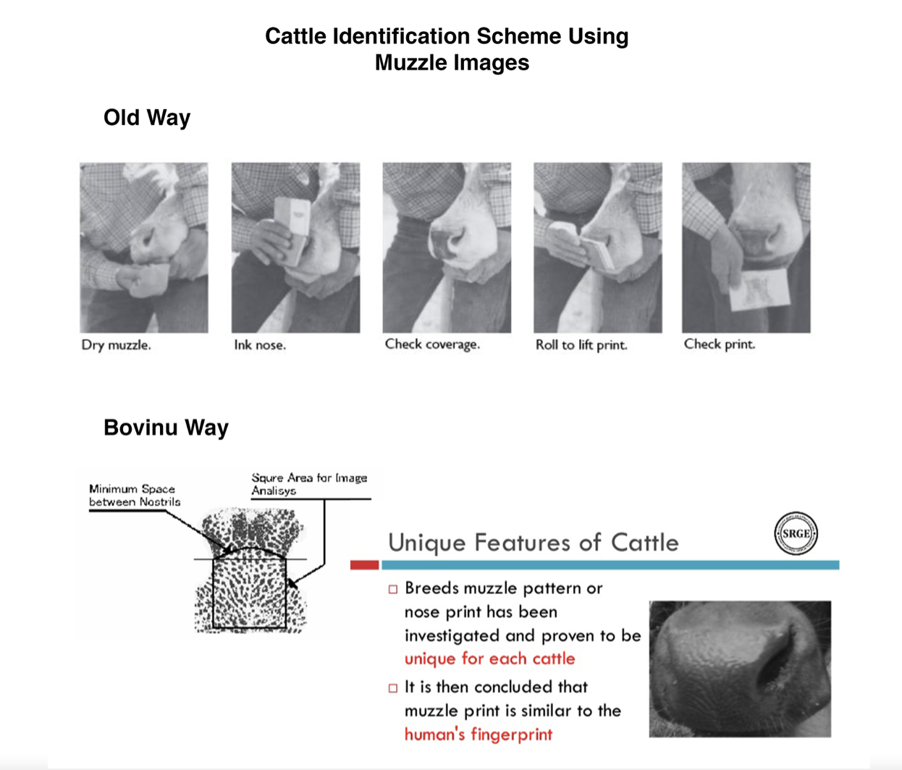

*Figure 5. Cattle Identification Scheme Using Muzzle Images.* (Gaber, 2014)

My proposed solution is an authentication platform requiring either physical touch or a phone camera. In the backend, this product may require a contactless authentication of 2D and 3D (depth) impressions of muzzle images.

There is a real opportunity here to create a system that will radically change the industry of farming, a system that is seamless and humane. The area of this project, if funded, could benefit the economy and the individual farmer, as well.

Real market applications include: Enable sale and purchase of animals, products, and services. Enable exchange of animals, products, and services. Create a space for farmers to connect and exchange helping info. The end goal will be the launch of a user-friendly platform by the summer 2019; a platform that is easy to navigate and use, just like Amazon. The value will be the humane treatment of animals which is inherent to my organization.

**“**Information systems and technologies are some of the most important tools available to managers for achieving higher levels of efficiency and productivity in business operations, […] Specifically, business firms invest heavily in information systems to achieve six strategic business objectives: operational excellence; new products, services, and business models; customer and supplier intimacy; improved decision making; competitive advantage; and survival.” (Laudon & Laudon, 2014)

For our project, I am suggesting this high and mid-level IT figure:

A cost-free database inventory sponsored by ads of drug companies & feed suppliers.

A Cow Identification System that allows users to trace or match a cow against a database.

A cloud-based list of top pure breeds semen, oocyte and embryo which are available for sale.

A clearinghouse, where users are quickly checking for product availability for a bull in the region closest to home.

Once expanded, it’s my opinion that it could be easy to imagine the impact of such applications. For instance, each user of our bio-tagging system can store the animal’s info, date of birth, milking speed, and any other updates relevant to their business. This software provides automated field registers, automated responses, and automated time estimation of daily milking according to an investigated report of the number of healthy cows available at the farm, the farm's current technology, and the physical availability of the farm employees.

# Thematic Analysis

To get the best results, let’s use OpenCV FLANN (Fast Approximate Nearest Neighbor Search) in conjunction with OpenCV ORB (Oriented FAST and Rotated BRIEF).

FLANN is a powerful and fast search algorithm for unique feature extraction. It uses only neighbor pixels. For this reason, it has very limited information regarding the edges and relative position between points. To have a more accurate read, it must be combined with other algorithms which take edges and rotations in consideration.

**The Testing Phase: Using FLANN with ORB to match features**

|  |  |  |  |  |  |  |  |  |  |  |  |  |  |  |  |  |  |  |  |  |  |  |  |  |  |  |  |  |  |  |  |  |  |  |  |  |  |  |  |  |  |  |  |  |  |  |  |  |  |  |  |  |  |  |  |  |  |  |  |  |  |  |  |  |  |  |  |  |  |  |  |  |  |  |  |  |  |  |  |  |  |  |  |  |  |  |  |  |  |  |  |  |  |  |  |  |  |  |  |  |  |  |  |  |  |  |  |
| --- | --- | --- | --- | --- | --- | --- | --- | --- | --- | --- | --- | --- | --- | --- | --- | --- | --- | --- | --- | --- | --- | --- | --- | --- | --- | --- | --- | --- | --- | --- | --- | --- | --- | --- | --- | --- | --- | --- | --- | --- | --- | --- | --- | --- | --- | --- | --- | --- | --- | --- | --- | --- | --- | --- | --- | --- | --- | --- | --- | --- | --- | --- | --- | --- | --- | --- | --- | --- | --- | --- | --- | --- | --- | --- | --- | --- | --- | --- | --- | --- | --- | --- | --- | --- | --- | --- | --- | --- | --- | --- | --- | --- | --- | --- | --- | --- | --- | --- | --- | --- | --- | --- | --- | --- | --- | --- | --- |
| |  |  |  |  |  |  |  |  |  |  |  |  |  |  |  |  |  |  |  |  |  |  |  |  |  |  |  |  |  |  |  |  |  |  |  |  |  |  |  |  |  |  |  |  |  |  |  |  |  |  |  |  |  |  |  |  |  |  |  |  |  |  |  |  |  |  |  |  |  |  |  |  |  |  |  |  |  |  |  |  |  |  |  |  |  |  |  |  |  |  |  |  |  |  |  |  |  |  |  |  |  |  | | --- | --- | --- | --- | --- | --- | --- | --- | --- | --- | --- | --- | --- | --- | --- | --- | --- | --- | --- | --- | --- | --- | --- | --- | --- | --- | --- | --- | --- | --- | --- | --- | --- | --- | --- | --- | --- | --- | --- | --- | --- | --- | --- | --- | --- | --- | --- | --- | --- | --- | --- | --- | --- | --- | --- | --- | --- | --- | --- | --- | --- | --- | --- | --- | --- | --- | --- | --- | --- | --- | --- | --- | --- | --- | --- | --- | --- | --- | --- | --- | --- | --- | --- | --- | --- | --- | --- | --- | --- | --- | --- | --- | --- | --- | --- | --- | --- | --- | --- | --- | --- | --- | | |  |  |  |  |  |  | | --- | --- | --- | --- | --- | --- | | CPU-based* Computer Vision | | | | | | |  | Number of Training Images | | | | | |  | N1 | N2 | N3 | N4 | N5 | | Speed of Extraction, Python - FLANN with ORB | 8.81 | 8.81 | 8.92 | 8.97 | 8.91 | | Speed of Extraction, SURF (in sec) | 8.81 | 8.82 | 8.91 | 8.96 | 8.91 | | Speed of Extraction, SIFT/RANSAC (in sec) | 9.31 | 9.31 | 9.32 | 9.34 | 9.32 | | CPU (central processing unit) is the power provided by the motherboard's internal processor |  |  |  |  |  | |  |  |  |  |  |  | |  |  |  |  |  |  | | GPU-enabled* Computer Vision (CUDA) | | | | | | |  | Number of Training Images | | | | | |  | N1 | N2 | N3 | N4 | N5 | | Speed of Extraction, Python - FLANN with ORB | 5.6 | 5.6 | 5.52 | 5.81 | 5.81 | | Speed of Extraction, SURF (in sec) | 5.6 | 5.6 | 5.53 | 5.84 | 5.84 | | Speed of Extraction, SIFT/RANSAC (in sec) | 5.74 | 5.74 | 5.64 | 6 | 5.82 | | GPU (Graphics Processing Unit) is accelerated computer power, notably used for big data studies and for self-driving cars | | | | | | |  |  |  |  |  | |  |  |  |  |  |
| *Figure 6: Comparing speed of OpenCV Flann/Orb against SURF, and SIFT/RANSAC*   |  |  |  |  |  |  | | --- | --- | --- | --- | --- | --- | | Accuracy Indicator | | | | | | |  | Number of Training Images | | | | | |  | N1 | N2 | N3 | N4 | N5 | | Accuracy Python - FLANN with ORB | 0.95 | 0.96 | 0.94 | 0.9 | 0.9 | | Kappa* Python - FLANN with ORB | 0.96 | 0.95 | 0.94 | 0.91 | 0.91 | | Accuracy SURF | 0.95 | 0.96 | 0.96 | 0.92 | 0.92 | | Kappa SURF | 0.94 | 0.97 | 0.97 | 0.91 | 0.91 | | Accuracy SIFT/RANSAC | 0.95 | 0.95 | 0.92 | 0.92 | 0.92 | | Kappa SIFT/RANSAC | 0.94 | 0.97 | 0.92 | 0.92 | 0.91 | | Kappa: A numerical rating of the degree to which an agreement between independent observers is expected. |  |  |  |  |  | | | | | | |

*Figure 7: Comparing accuracy of OpenCV Flann/Orb against SURF, and SIFT/RANSAC*

# Interpreting the Results

1. **A Linear Outcome**

The SIFT/RANSAC pair is thought to be one of the most reliable pattern-matching algorithms. It’s a sophisticated algorithm with a meek channel of successors. The accuracy indicator indicates an almost parallel orientation. I was hoping for more distance, it's true. But

this shows that Python FLANN/ ORB is a viable player in the arena of features matching. Although it would need more altering to become one of the best, which it isn’t yet.

1. **Experimental Limitations**
2. **Hardware Requirements**

In terms of GPU requirements, I use one NVIDIA GTX 1080 TI card (12 cores). This card is especially high in memory and can be relied on to train the network in a very short amount of time and then to have the image subjects tested quickly. GPU settings aren’t cheap. Ideally, engineers will mount up to 10 (sometimes more) graphics cards to bump their GPU speed power. Especially of interest in our domain is the possibility to figuratively plug your machine to a cloud network, such as Google Cloud. It leverages the use of higher amounts of GPUs.

1. **Training the Machine**

It is no secret that in the field of Machine Learning, the more you train your network the better the expected results will be. When it comes to complex matrix studies, one to several weeks sometimes is required.

1. **Computationally Expensive**

Applying an algorithm to a great number of locations and scales which are inside an image can be computationally expensive. The way I went around it for this project was to utilize a limited set of testing photographs, which were clear of foreign objects like a finger or a second cow, for example. This is, of course, called thresholding, a term explained in detail in the ensuing section. It’s important to point out that, by classifying the original muzzle in respect of its shapes rather than the detailing in the skin—the tiny knobs on their nose surface, and there are hundreds of them—we expertly divert from a quaestio that could be acutely difficult to tackle, otherwise.

1. **The Competition**

The aptness of a company to provide Computer Vision comes with expectations of dependability. It comes as no surprise that the competition in that sphere is going to be wholesome. I think there is plenty of rewards in building a proprietary system, yet one must not forget there are others that will be possibly better or faster. *The good news, rarely a single computer algorithm will be good at everything, every time…*

# Reference Guidelines

In this section we are looking at computer vision in real time, some of the techniques I use to compare images using python, and why in my opinion python is the best choice to be integrated in our pattern-matching system.

“Only with the latest developments in AI has truly great computer vision become possible.” (Moser, 2017)

1. **Computer vision**

First, it’s important to understand colors in the context of computer science. In Python, colors are represented by coordinates in the form of (B,G,R) that stands for a value of blue, red and green respectively. When converting an image to gray, you end up with a single channel instead (0,255). For a program, handling a gray image would mean less computational cost. Depending on the project you are working on, this could be an advantage.

1. **Thresholding**

“Thresholding is often used to filter specific areas of an image with specific (color) properties. One thresholding method is binary thresholding in which you define a threshold and receive a black and white image as output. All pixels that exceed the threshold are white while the other pixels are black.” (Moser, 2017)

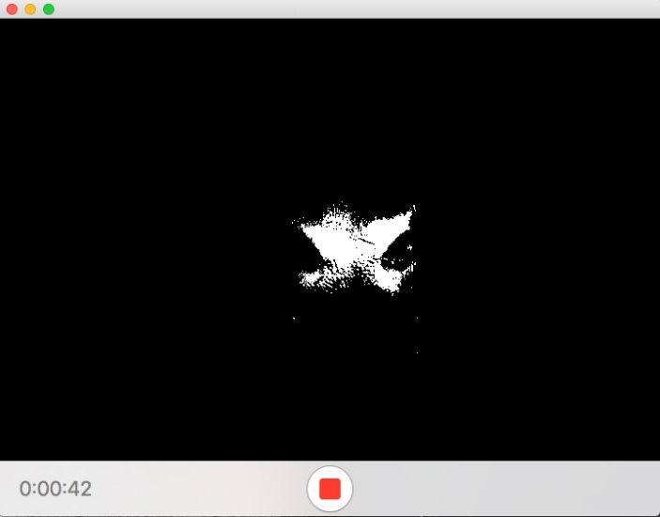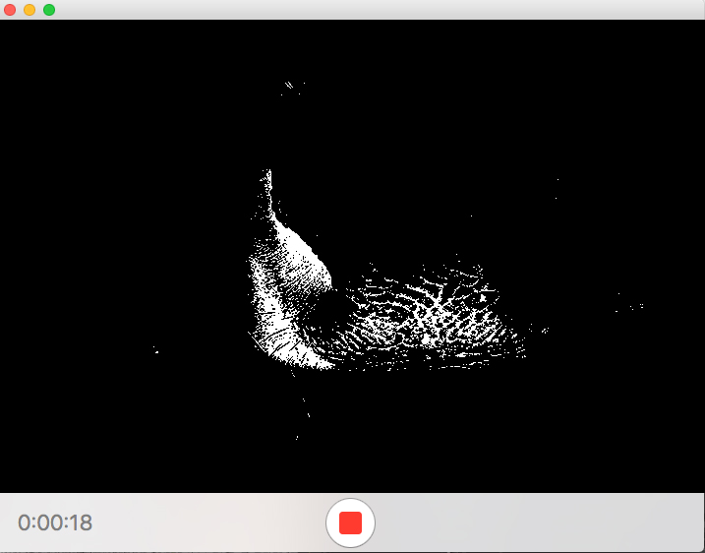

*Figure 8: Webcam stream, and thresholding command.*

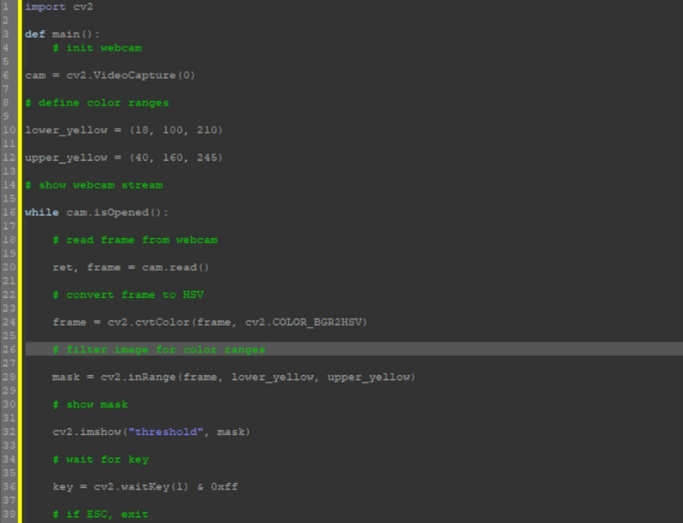

*Figure 9: This OpenCV code was borrowed from DZone.com*

1. **Defining the Values to keep**

This is done using extraction and blob detection. A blob represents a group of connected pixels in an image that share similarities.

# **Conclusion**

The next big thing, if we do verify cattle ID, would change our perspective much as Face ID did a couple years ago. I showed you that the well-established, feature-detection algorithms are not complete. That’s why it's more important to understand the subject rather than the programming language, and yet we're lucky to have OpenCV and Python. I think it's a great way to build portable technologies that are connected to the cloud.

It's good for the field of computer vision that we have such a variety of algorithms. I'm not discouraged by this in by any means because we know that new computer science must be competitive. My project will need at least two years of improvements and updates to become a reality and when I finally return to it I hope to acquire enough funding to create a physical system. Although, almost all my models could be ruled out in the event a more efficient programming language evolves for microcontrollers. Python is becoming more popular among developers, and Micro Python is the programming language of choice for creative scientists like me. There is a very nice sentence by University of Cambridge theoretical physicist Damien George—Micro Python founder—who says, “I needed something very small, but powerful — something with a lot of input and output lines that I was able to precisely control […]" (Venkataramanan, 2013)

I just spent a year researching and experimenting this Cattle ID because my collaborator and I have discovered the need for it. This work is about convenience for the user, but it’s also about the value and welfare of farm animals.

Why do we like new technologies and why do we keep purchasing them? Those things need to be as important for our convenience as they are ethical. The small tools that we create are the very things that make us human.

# **References**

A. K. Jain, A. A. (2011). *Introduction to Biometrics.* Springer.

Bojinov, H., Boneh, D., Michalevsky, Y., & Nakibly, G. (2015). *Mobile Device Identification via Sensor Fingerprinting.* Retrieved November 25, 2017, from stanford.edu: https://crypto.stanford.edu/gyrophone/sensor_id.pdf

Bolton, D. (2017, August 3). *Exploring the Benefits of MicroPython*. Retrieved from Dice: https://insights.dice.com/2017/08/03/exploring-benefits-micropython/

Derpanis, K. G. (2010, May 13). *Overview of the RANSAC Algorithm*. Retrieved 10 10, 2017, from rmozone: http://rmozone.com/snapshots/2015/07/cdg-room-refs/ransac.pdf

Finkenzeller, K. (2010). *RFID Handbook: Fundamentals and Applications in Contactless Smart Cards, Radio Frequency Identification and Near-Field Communication.* Chichester West Sussex: John Wiley & Sons, Ltd.

Fontana, J. (2015, December 04). *Apple's fingerprint reader missing one special touch*. Retrieved November 27, 2017, from zdnet: from http://www.zdnet.com/article/apples-fingerprint-reader-missing-one-special-touch/

Gaber, D. T. (2014, October). *Precision livestock farming cattle identification based on biometric data by Dr. Tarek Gaber*. Retrieved November 10, 2017, from Slideshare: https://www.slideshare.net/Tarekgaber/precision-livestock-farming-cattle-identification-based-on-biometric-data-tarek-gaber-40692911

Giot, R., El-Abed, M., & Rosenberger, C. (2013). Fast Computation of the Performance Evaluation of Biometric Systems: Application to Multibiometrics. *Future Generation Computer Systems* , 788-799.

GobalHarvestInitiative.org. (2016, January 28). *Bridging the Gap between Farmers and Capital*. Retrieved from Gobal Harvest Initiative: https://www.globalharvestinitiative.org/2016/01/bridging-the-gap-between-farmers-and-capital/

Goode, A. (2015, March 01). *WEARABLE BIOMETRIC IDENTITY – IDENTITY GETS VERY PERSONAL*. Retrieved November 25, 2017, from connectidexpo: http://www.connectidexpo.com/creo_files/2015_day2/15.50%20Alan%20Goode_Goode%20Intelligence%20-%20Wearable%20Biometric%20Identity%20-%20Connect%20ID%202015.pdf

Hill, C. (2015). *Biometric Technology Today.* new York: Elsevier.

Laudon, K. C., & Laudon, J. P. (2014). *Management Information Systems: Managing the Digital Firm, 13th Edition.* London: Pearson.

Leary, A. (2016, January). *Bridging the Gap-Between Farmers and Capital*. Retrieved September 18, 2018, from globalharvestinitiative.org: https://www.globalharvestinitiative.org/2016/01/bridging-the-gap-between-farmers-and-capital/

Mordvintsev, A., & K., A. (2013). *Introduction to SURF (Speeded-Up Robust Features*. Retrieved from OpenCV Python Tutorials: https://opencv-python-tutroals.readthedocs.io/en/latest/py_tutorials/py_feature2d/py_surf_intro/py_surf_intro.html

Moser, O. (2017, July 31). *Introduction to Computer Vision With OpenCV and Python*. Retrieved from Dzone: https://dzone.com/articles/introduction-to-computer-vision-with-opencv-and-py

Noviyanto, A., & Arymurthy, A. (2012). Automatic Cattle Identification based on Muzzle Photo Using Speed-Up Robust Features Approach. *Proceedings of the 3rd European Conference of Computer Science*, (pp. 110-114).

Oklahoma Cooperative Extension Service • Division of Agricultural Sciences and Natural Resources. (24, May 2007). *Some Ways to Identify Beef Cattle*. Retrieved November 09, 2017, from http://oklahoma4h.okstate.edu: http://oklahoma4h.okstate.edu/litol/file/animal/beef/N-612_web.pdf

Oklahoma Cooperative Extension Service. (2004). *Some Ways to Identify Beef Cattle*. Retrieved November 04, 2017, from okstate.edu: http://oklahoma4h.okstate.edu/litol/file/animal/beef/N-612_web.pdf

Oklahoma Cooperative Extension Service. (2004, May 24). *Some Ways To Indentify Beef Cattle*. Retrieved November 09, 2017, from okstate.edu.

*OpenCV*. (2018). Retrieved from opencv.org: https://opencv.org/

Resources, O. C. (2007, May 24). *Some Ways to Identify Beef Cattle*. Retrieved November 09, 2017, from okstate.edu/: http://oklahoma4h.okstate.edu/litol/file/animal/beef/N-612_web.pdf

SRGE. (2013). A Robust Cattle Identification Scheme Using Muzzle Print Images. *Proceedings of the 2013 Federated Conference on Computer Science and Information Systems*, (pp. 529-534). Egypt.

*The future lies in biometrics*. (2018, June 04). Retrieved from The DRUM: https://www.thedrum.com/opinion/2018/06/04/the-future-lies-biometrics

Ur, B. (2017, August 20). *Biometric Authentication on iPhone and Android: Usability, Perceptions, and Influences on Adoption*. Retrieved November 17, 2017, from blaseur.com: http://www.blaseur.com/papers/usec15-biometrics.pdf

USDA. (2017). *Farm Computer Usage and Ownership.* United States Department of Agriculture.

Venkataramanan, M. (2013, December 06). *Micro Python: more powerful than Arduino, simpler than the Raspberry Pi*. Retrieved from Wired Co UK: https://www.wired.co.uk/article/micro-python

W.E.Petersen. (1922). The Identification of the Bovine by Means of Nose-Prints. *Journal of Dairy Science*, 249-257.

Zhang, L. (2018, September 18). *Self Attention Mechanisms in Natural Language Processing*. Retrieved from DZone - AI Zone : https://dzone.com/articles/self-attention-mechanisms-in-natural-language-proc

Zurich, E., & Leuven, L. (2008). Speeded-Up Robust Features (SURF). *ScienceDirect*, 346-347.